# Exercise 4 - In-Lab Task

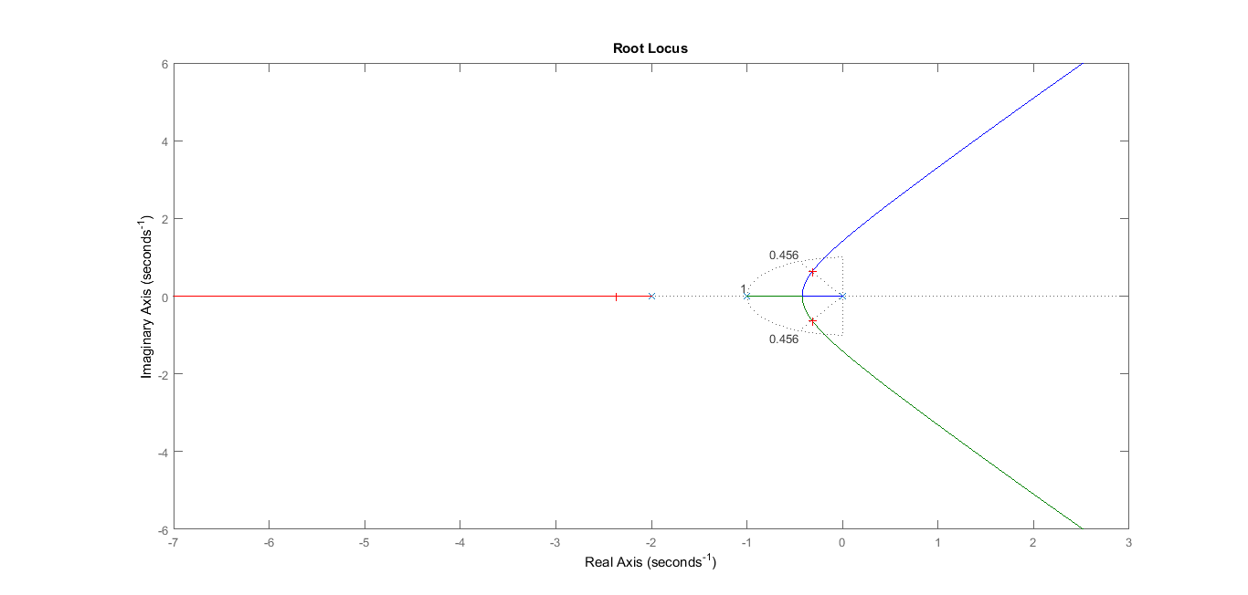

Figure 1. Root Locus

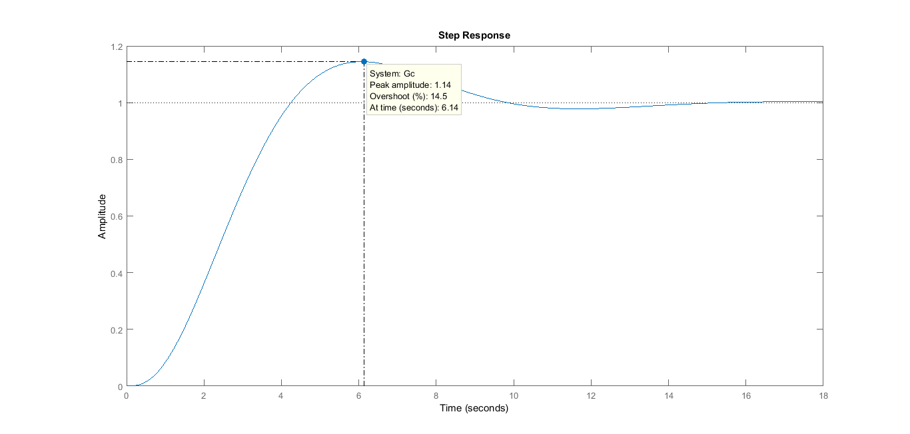

Figure 2. Step Response of Uncompensated System

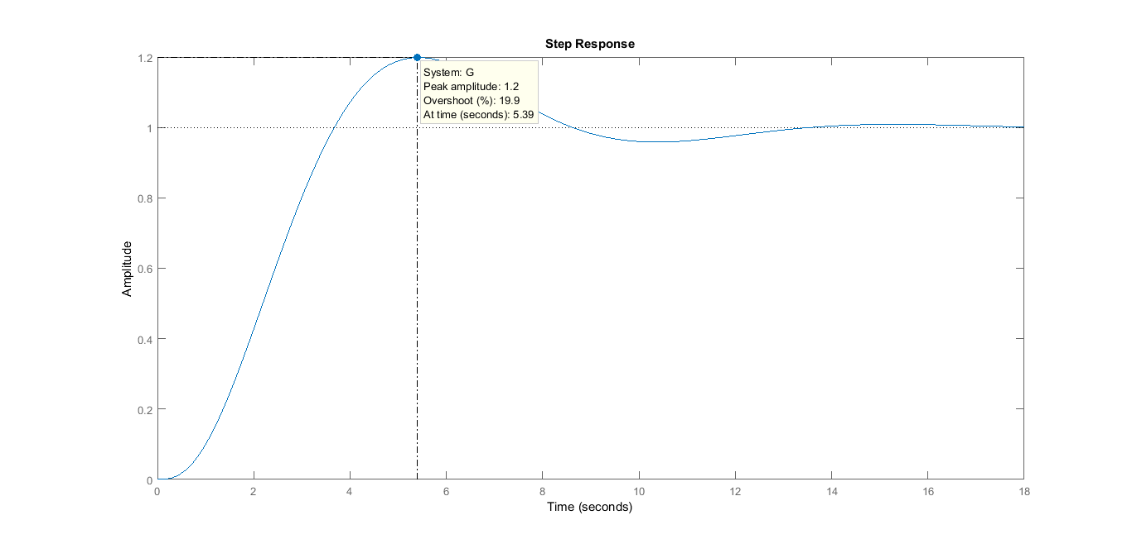

Figure 3. Step Response of Compensated System